**DATA ANALYSIS QUERIES**

Query 1:

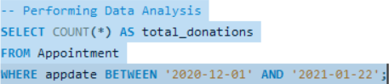

Query 2:

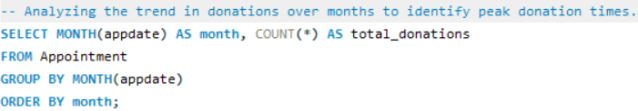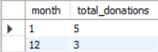

Query 3:

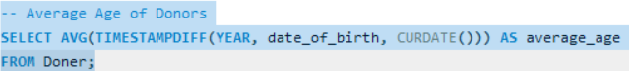

Query 4:

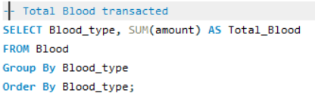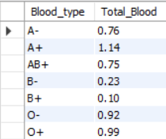

Query 5:

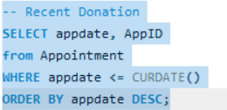

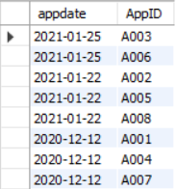

Query 6:

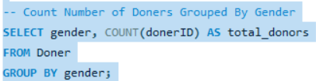

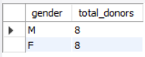

Query 7:

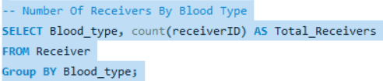

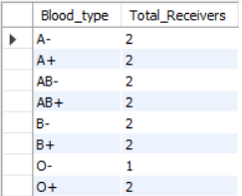

Query 8:

